KMEANS

elbow method

strategy kmeans ++ or random related to number of clusters algorithm - Iloyd

wcss within cluster sum of squars we get elbow shape cureve we get inertia how to check the performance of kmeans?

import numpy as np import pandas as pd import seaborn as sns

In [1]:

In [2]:

df = pd.read_csv("D:\MIT ADT\Third Year - Sem 2\ML LAB\Assign 8 - kmea\onli ne_shoppers_intention. shoppers_intention csv")

In [3]:

df.head()

|  |  |  |  |  |  |  |
| --- | --- | --- | --- | --- | --- | --- |
| Out[3]: |  | | | | | |
|  |  | **Administrative** | **Administrative_Duration** | **Informational** | **InformationaI_Duration** | **ProductRelate** |
|  | 0 | 0 | 0.0 | 0 | 0.0 |  |
|  | 1 | 0 | 0.0 | 0 | 0.0 |  |
|  | 2 | 0 | 0.0 | 0 | 0.0 |  |
|  | 3 | 0 | 0.0 | 0 | 0.0 |  |
|  | 4 | 0 | 0.0 | 0 | 0.0 | 1 |



|  |  |  |
| --- | --- | --- |
| In [4]: | df.isna().sum() |  |
| Out[4]: | Administrative | 0 |
|  | Administrative_Duration | 0 |
|  | Informational | 0 |
|  | Informational_Duration | 0 |
|  | ProductRelated | 0 |
|  | ProductRelated_Duration | 0 |
|  | BounceRates | 0 |
|  | ExitRates | 0 |
|  | PageValues | 0 |
|  | SpecialDay | 0 |
|  | Month | 0 |
|  | OperatingSystems | 0 |
|  | Browser | 0 |
|  | Region | 0 |
|  | TrafficType | 0 |
|  | VisitorType | 0 |
|  | Weekend | 0 |
|  | Revenue  dtype: int64 | 0 |

In [ 5] :

df.duplicated().sum()

Out[5]: 125

In [6]:

df = df.drop_duplicates()

In [7]:

df.head()

|  |  |  |  |  |  |  |
| --- | --- | --- | --- | --- | --- | --- |
| Out[7]: |  | | | | | |
|  |  | **Administrative** | **Administrative_Duration** | **Informational** | **lnformationaI_Duration** | **ProductRelate** |
|  | 0 | 0 | 0.0 | 0 | 0.0 |  |
|  | 1 | 0 | 0.0 | 0 | 0.0 |  |
|  | 2 | 0 | 0.0 | 0 | 0.0 |  |
|  | 3 | 0 | 0.0 | 0 | 0.0 |  |
|  | 4 | 0 | 0.0 | 0 | 0.0 | 1 |



In [8]:

df.info()

<class 'pandas.core.frame.DataFrame'> Index: 12205 entries, 0 to 12329

Data columns (total 18 columns):

# Column Non-Null Count Dtype

|  |  |  |  |
| --- | --- | --- | --- |
| 0 Administrative | 12205 | non-null | int64 |
| 1 Administrative_Duration | 12205 | non-null | float64 |
| 2 Informational | 12205 | non-null | int64 |
| 3 Informational_Duration | 12205 | non-null | float64 |
| 4 ProductRelated | 12205 | non-null | int64 |
| 5 ProductRelated_Duration | 12205 | non-null | float64 |
| 6 BounceRates | 12205 | non-null | float64 |
| 7 ExitRates | 12205 | non-null | float64 |
| 8 PageValues | 12205 | non-null | float64 |
| 9 SpecialDay | 12205 | non-null | float64 |
| 10 Month | 12205 | non-null | object |
| 11 OperatingSystems | 12205 | non-null | int64 |
| 12 Browser | 12205 | non-null | int64 |
| 13 Region | 12205 | non-null | int64 |
| 14 TrafficType | 12205 | non-null | int64 |
| 15 VisitorType | 12205 | non-null | object |
| 16 Weekend | 12205 | non-null | bool |
| 17 Revenue | 12205 | non-null | bool |

dtypes: bool(2), float64(7), int64(7), object(2) memory usage: 1.6+ MB

In [9]:

df_num df.select_dtypes(include=[”int64",'float64']).columns

In [10]:

Q1 = df[df_num].quantile(0.25) Q3 = df[df_num].quantile(0.75)

IQR = Q3 - Q1

outliers ((df[df_num]<(Q1-1.5*IQR))| df[df_num]>(Q3+1.5*IQR)).any(axis=1) df_no_outliers = df[-outliers]

In [11]:

df.shape

Out[11]: (12205, 18)

In [12]:

Out [ 12] :

(35, 18)

df_no_outliers.shape

In [13]:

sns.boxplot (df)

Out[13]: <Axes: >

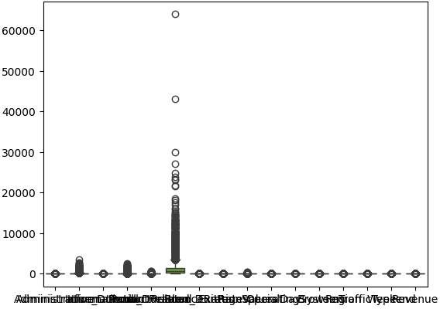

In [14]:

# Out [14] :

In [15]:

from sklearn.preprocessing import LabelEncoder

lbl_enc = LabelEncoder()

sns.boxplot(df_no_outliers)

# ‹Axes: ›

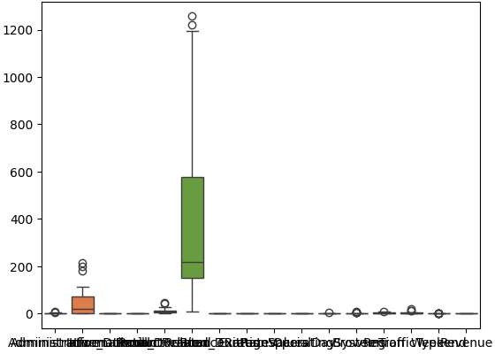

In [16]:

cols = ["Month", "VisitorType", "Weekend", "Revenue"]

for i in cols:

df_no_outliers[i] lbl_enc.fit_transform(df_no_outliers[i])

C:\Users\nilesh\AppData\Local\Temp\ipykernel_22032\3984002896.py:4: Setting WithCopyWarning:

A value ls trying to be set on a copy of a slice from a DataFrame. Try using .loc[row_indexer,col_indexer] = value instead

See the caveats in the documentation: https://pandas.pydata.org/pandas-doc s/stable/user_guide/indexing.html#returning-a-view-versus-a-copy

df_no_outliers[i] lbl_enc.fit_transform(df_no_outliers[i]) C:\Users\nilesh\AppData\Local\Temp\ipykernel_22032\3984002896.py:4: Setting WithCopyWarning:

A value is trying to be set on a copy of a slice from a DataFrame. Try using .loc[row_indexer,col_indexer] = value instead

See the caveats in the documentation: https://pandas.pydata.org/pandas-doc s/stable/user_guide/indexing.html#returning-a-view-versus-a-copy

df_no_outliers[i] lbl_enc.fit_transform(df_no_outliers[i]) C:\Users\nilesh\AppData\Local\Temp\ipykernel_22032\3984002896.py:4: Setting WithCopyWarning:

A value is trying to be set on a copy of a slice from a DataFrame. Try using .loc[row_indexer,col_indexer] = value instead

See the caveats in the documentation: https://pandas.pydata.org/pandas-doc s/stable/user_guide/indexing.html#returning-a-view-versus-a-copy

df_no_outliers[i] lbl_enc.fit_transform(df_no_outliers[i]) C:\Users\nilesh\AppData\Local\Temp\ipykernel_22032\3984002896.py:4: Setting WithCopyWarning:

A value is trying to be set on a copy of a slice from a DataFrame. Try using .loc[row_indexer,col_indexer] = value instead

See the caveats in the documentation: https://pandas.pydata.org/pandas-doc s/stable/user_guide/indexing.html#returning-a-view-versus-a-copy

df_no_outliers[i] lbl_enc.fit_transform(df_no_outliers[i])

In [17]:

df.head()

|  |  |  |  |  |  |  |
| --- | --- | --- | --- | --- | --- | --- |
| Out[17]: |  | | | | | |
|  |  | **Administrative** | **Administrative_Duration** | **Informational** | **InformationaI_Duration** | **ProductRelate** |
|  | 0 | 0 | 0.0 | 0 | 0.0 |  |
|  | 1 | 0 | 0.0 | 0 | 0.0 |  |
|  | 2 | 0 | 0.0 | 0 | 0.0 |  |
|  | 3 | 0 | 0.0 | 0 | 0.0 |  |
|  | 4 | 0 | 0.0 | 0 | 0.0 | 1 |



In [18]:

df.shape

Out[18]: (12205, 18)

In [19]:

X = df_no_outliers.iloc[:, [5,7]].values

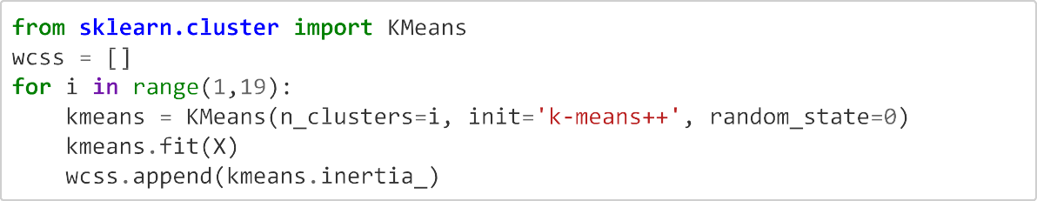



from sklearn.cluster import KMeans

wcss = []

for i in range(1, 19):

    kmeans_model = KMeans(n_clusters=i, init='k-means++', random_state=0)

    kmeans_model.fit(X)

    wcss.append(kmeans_model.inertia_)

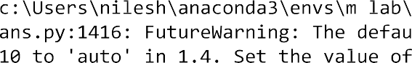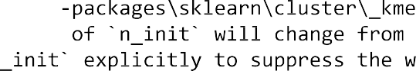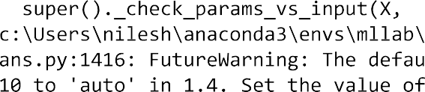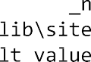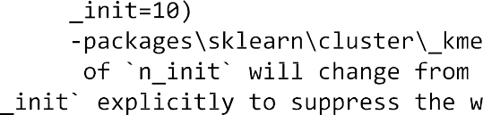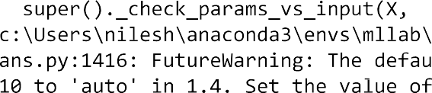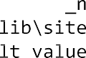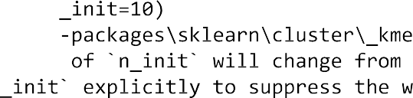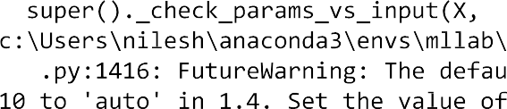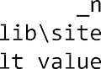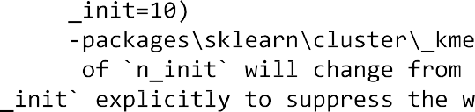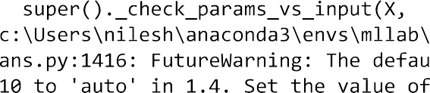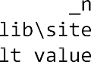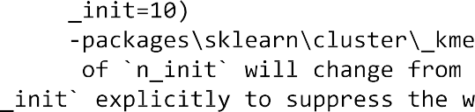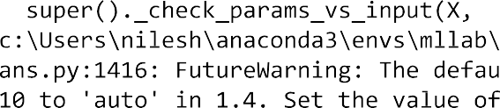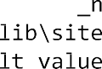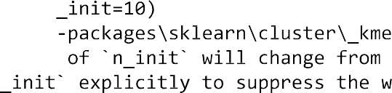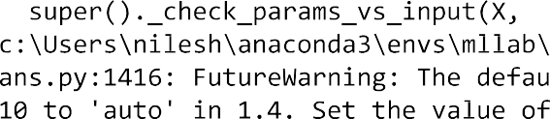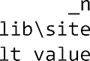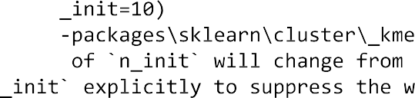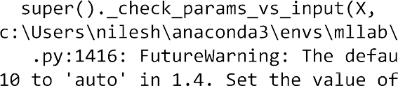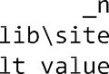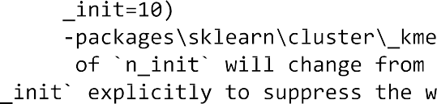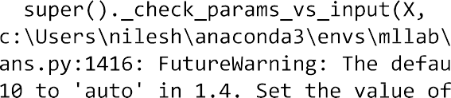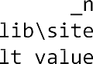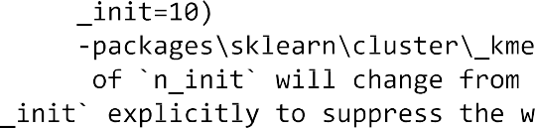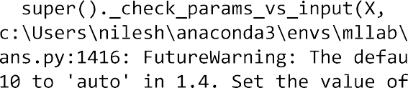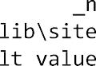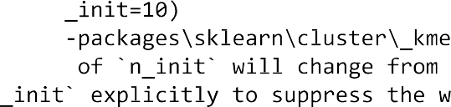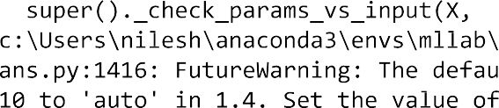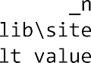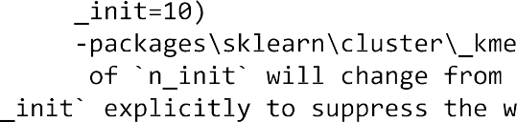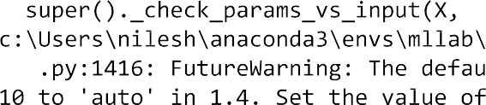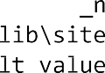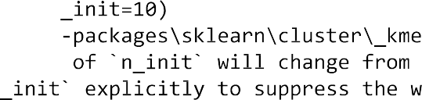

ans.py:1416: FutureWarning: The default value of ’n_init’ will change from

10 to 'auto' in 1.4. Set the value of ’n_init’ explicitly to suppress the w arning

super()._check_params_vs_input(X, default_n_init=10) c:\Users\nilesh\anaconda3\envs\mllab\lib\site-packages\sklearn\cluster\_kme ans.py:1416: FutureWarning: The default value of ’n_init will change from

10 to 'auto' in 1.4. Set the value of n_init’ explicitly to suppress the w arning

super()._check_params_vs_input(X, default_n_init=10) c:\Users\nilesh\anaconda3\envs\mllab\lib\site-packages\sklearn\cluster\_kme ans.py:1416: FutureWarning: The default value of ’n_init’ will change from

10 to 'auto' in 1.4. Set the value of ’n_init’ explicitly to suppress the w arning

super()._check_params_vs_input(X, default_n_init=10) c:\Users\nilesh\anaconda3\envs\mllab\lib\site-packages\sklearn\cluster\_kme ans.py:1416: FutureWarning: The default value of ’n_init will change from

10 to 'auto' in 1.4. Set the value of ’n_init’ explicitly to suppress the w arning

super()._check_params_vs_input(X, default_n_init=10) c:\Users\nilesh\anaconda3\envs\mllab\lib\site-packages\sklearn\cluster\_kme ans.py:1416: FutureWarning: The default value of ’n_init’ will change from

10 to 'auto' in 1.4. Set the value of n_init’ explicitly to suppress the w arning

super()._check_params_vs_input(X, default_n_init=10) c:\Users\nilesh\anaconda3\envs\mllab\lib\site-packages\sklearn\cluster\_kme ans.py:1416: FutureWarning: The default value of n_init’ will change from

10 to 'auto' in 1.4. Set the value of ’n_init’ explicitly to suppress the w arning

super()._check_params_vs_input(X, default_n_init=10)

|  |  |
| --- | --- |
| In [21]: | wcss |
| Out [ 21] : | [4225914. 6295909155, |
|  | 1003299.6184623878, |
|  | 374968.8579336218, |
|  | 211039.12310383684, |
|  | 112048.86693438172, |
|  | 67740.35789222053, |
|  | 44634.969755806276, |
|  | 32225.003806632685, |
|  | 22708.809410950165, |
|  | 13396.441698160002, |
|  | 8476.904178670138, |
|  | 6733.9474197431755, |
|  | 5193.143669743172, |
|  | 4133.492078667702, |
|  | 3493.159484970106, |
|  | 2689.0161983962225, |
|  | 2088.34934721141, |

1665.8940237220372]

In [22]:

import matplotlib.pyplot as pit plt.figure(figsize=(10,5))

plt.plot(range(1, 19), wcss,marker='o',color='red') plt.title('The Elbow Method')

plt.xlabel('Number of clusters') plt.ylabel('WCSS')

plt.show()

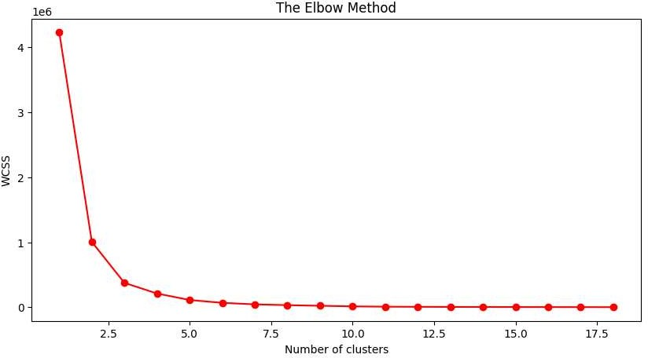

In [23]:

kmeans = KMeans(n_clusters=2, init='k-means++', random_state=42) y_kmeans = kmeans.fit_predict(X)

c:\Users\nilesh\anaconda3\envs\mllab\lib\site-packages\sklearn\cluster\_kme ans.py:1416: FutureWarning: The default value of ’n_init’ will change from

10 to 'auto' in 1.4. Set the value of ’n_init’ explicitly to suppress the w arning

super()._check_params_vs_input(X, default_n_init=10)

In [24]:

y_kmeans

Out [ 24] :

array([0, 0, 0, 0, 0, 0, 0, 0, 0, 1, 0, 0, 0, 0, 0, 1, 0, 0, 0, 1, 0, 1,

1, 1, 0, 0, 0, 0, 0, 0, 1, 1, 0, 0, 1])

|  |  |  |  |  |  |  |
| --- | --- | --- | --- | --- | --- | --- |
| In [25]: | plt.figure(figsize=(15,7)) |  | | | | |
|  | plt.scatter(X[y_kmeans == | 0, | 0], | X[y_kmeans == 0, | 1], | color = 'yellow', lab |
|  | el = 'Cluster 1',s=50) |  |  |  |  |  |
|  | plt.scatter(X[y_kmeans == | 1, | 0], | X[y_kmeans == 1, | 1], | color = 'blue', label |
|  | = 'Cluster 2',s=50)  *#pLt. scatt er(X[y_é*/r *eans ————* | *2,* | *8),* | *X[y _b*/r *eans ———— 2,* | *1),* | *coLon —— ’green ’, Lab* |
|  | *eL -— CLus ter 3 ', s-—58)* |  |  |  |  |  |
|  | plt.scatter(kmeans.cluster_centers_[:, 0], kmeans.cluster_centers_[:, 1], c  olor = 'red',  label = 'Centroids',s=300,marker=',')  plt.grid(False) plt.title('Clusters of customers')  plt.xlabel('ProductRelated_Duration') plt.ylabel('ExitRates')  plt.legend() plt.show() | | | | | |

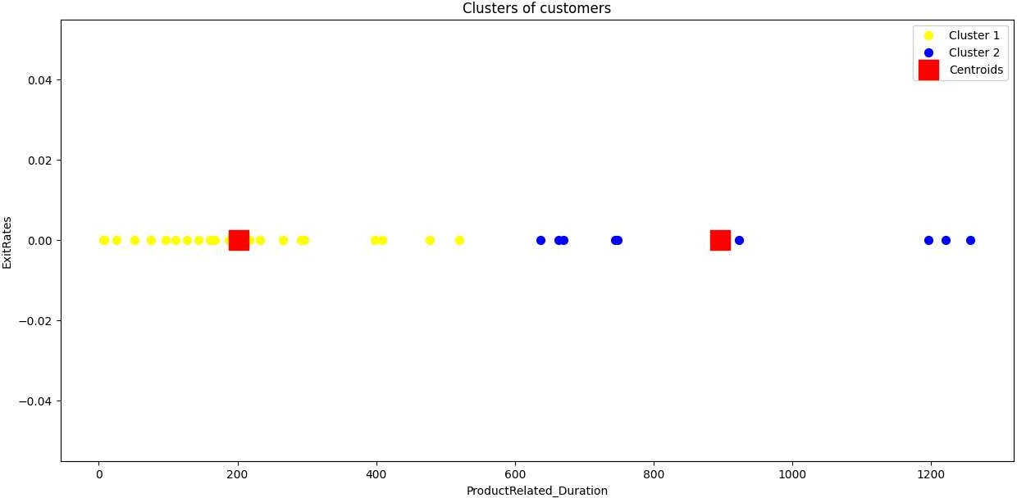

CHECK PERFORMACE OF KMEANS, silhouette score - best value = 1, worst value = -1

sklearn.metrics.silhouette_score(X, labels, *, metric='eucIidean', sampIe_size=None, random_state=None,

**kwds)

Parameters: X{array-like, sparse matrix} of shape (n sampIes_a, n sampIes_a) if metric == “precomputed” or (n_sampIes_a, n_features) otherwise An array of pairwise distances between samples, or a feature array.

labelsarray-like of shape (n_sampIes,) Predicted labels for each sample.

metricstr or callable, defauIt=’eucIidean’ The metric to use when calculating distance between instances in a feature array. If metric is a string, it must be one of the options allowed by pairwise distances. If X is the distance array itself, use metric="precomputed".

sampIe_sizeint, defauIt=None The size of the sample to use when computing the Silhouette Coefficient on a random subset of the data. If sampIe_size is None, no sampling is used.

random_stateint, RandomState instance or None, defauIt=None Determines random number generation for selecting a subset of samples. Used when sampIe_size is not None. Pass an int for reproducible results across multiple function calls. See Glossary.

**kwdsoptional keyword parameters Any further parameters are passed directly to the distance function. If using a scipy.spatial.distance metric, the parameters are still metric dependent. See the scipy docs for usage examples.

In [26]:

from sklearn.metrics import silhouette_score

silhouette_score(X, kmeans.fit_predict(X))

c:\Users\nilesh\anaconda3\envs\mllab\lib\site-packages\sklearn\cluster\_kme ans.py:1416: FutureWarning: The default value of ’n_init’ will change from

10 to 'auto' in 1.4. Set the value of ’n_init’ explicitly to suppress the w arning

super()._check_params_vs_input(X, default_n_init=10) Out[26]: 0.6991303676252153